St Margaret’s and St George’s
United Reformed and Moravian
Church Hall
Nicoll Road, Harlesden, London NW10 9AX

Come and join us
Free Presentation by the Men’s Fellowship

Saturday 25th July 2026
Start at 11am

Health Presentation and Discussion

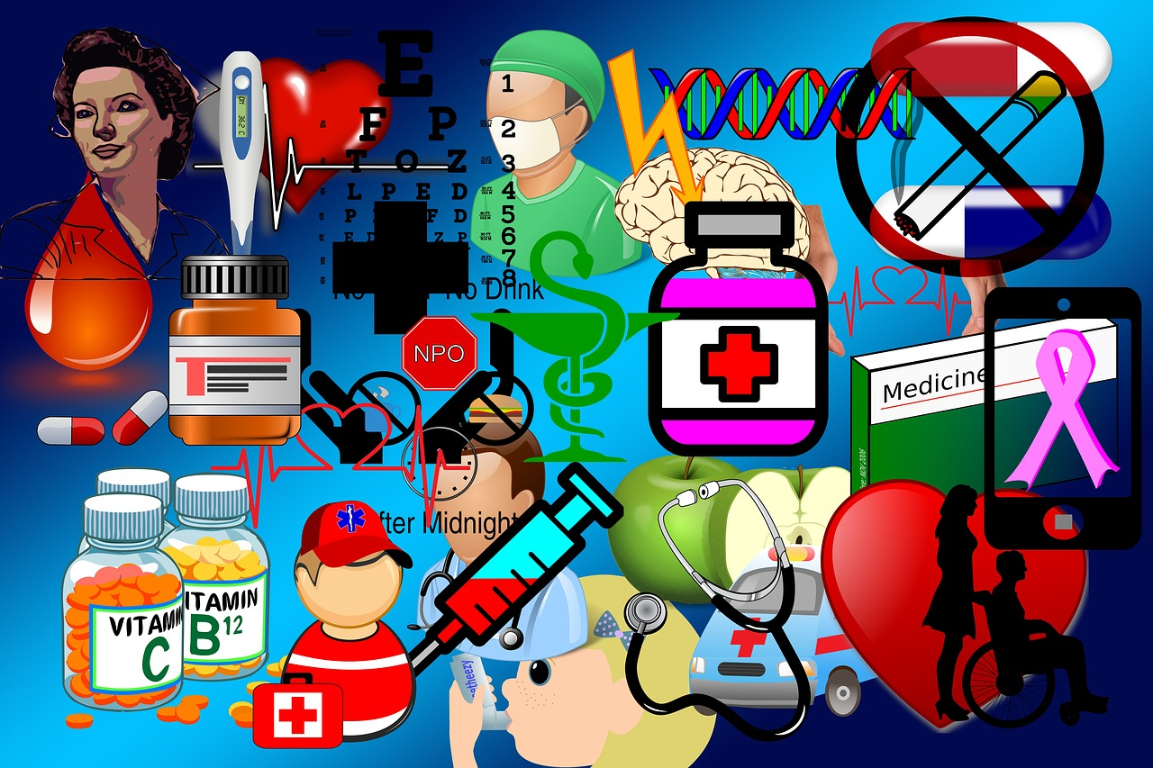

Theme : Diabetes and Hypertension, High Blood Pressure

Speakers:
Dr B. Awadzi (Medical Doctor)

